**NAME: ABDURRAHMAN QURESHI**

**ROLL NO: 210451**

**EXP6**

**Web page to link different branches of your colleges.**

__________________________________________________________________________________

**Code:**

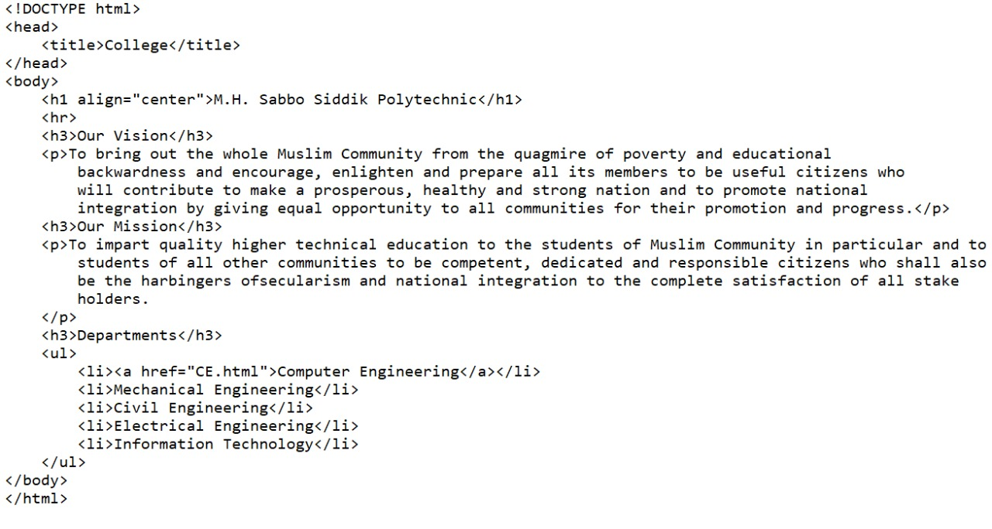

__________________________________________________________________________________

**Output:**

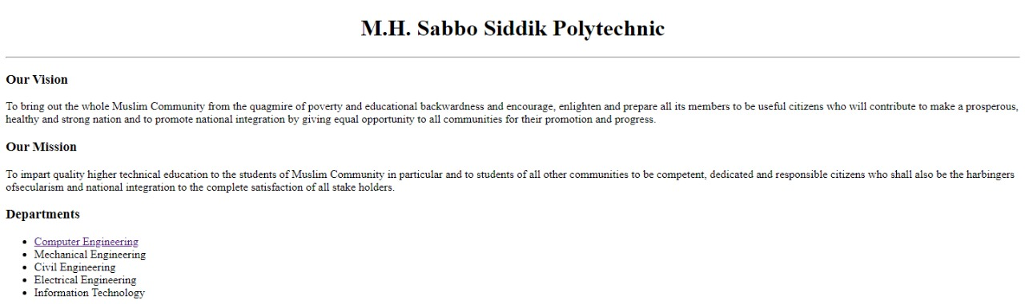

**Computer page code:**

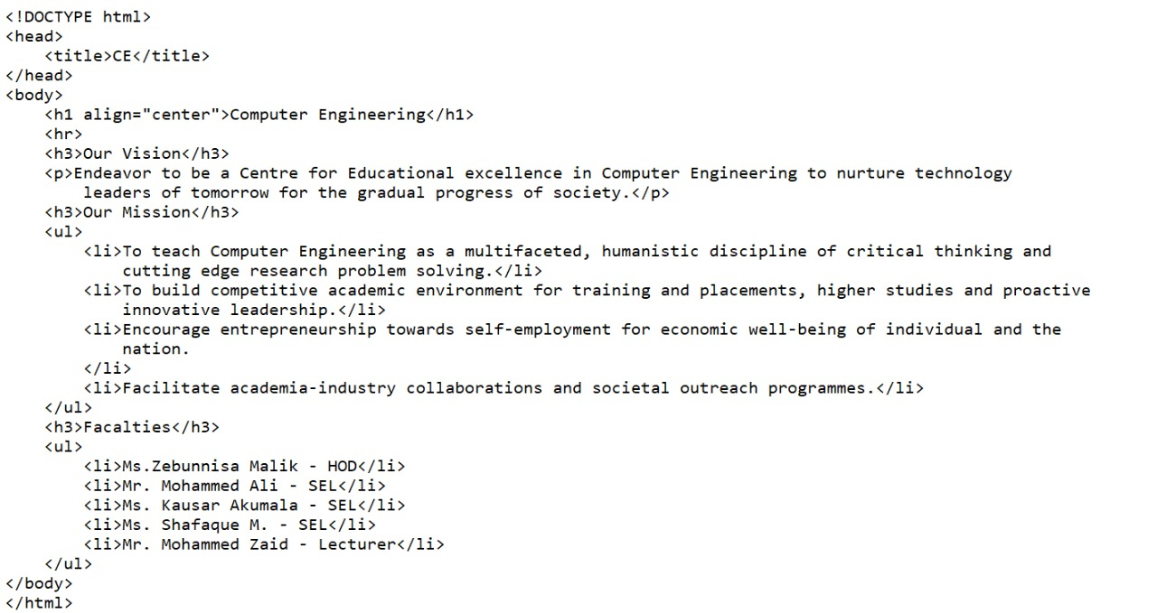

__________________________________________________________________________________

**Output:**

